Tutorial: 2

Name: Chalani Saumya Rajapakshe

Id: IT21377280

Exercise- 01

01.)

02.)

03.)

04.)

05.)

06.)

07.)

8.)

Exercise- 02.a

01.)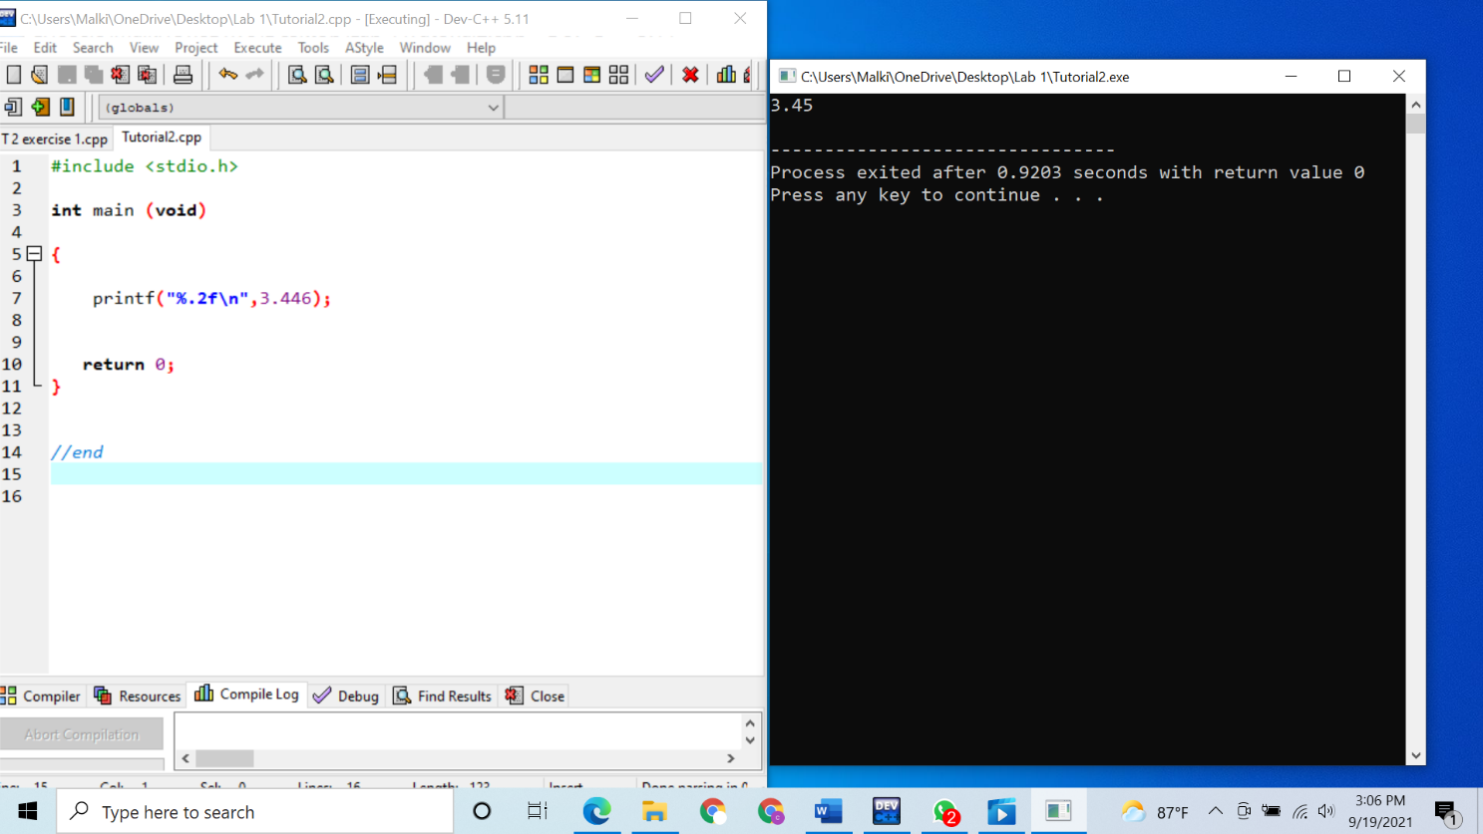

02.)

Exercise -02.b

01.)

02.)

03.)

Exercise -03

01.)

2.)

03.)

04.)

Exercise -04

